**BACKING UP THE ETCD CLUSTER DATA**

**TASKS:**

1. Backing up the etcd cluster data

2. Creating and verifying the namespaces

3. Generating a certificate and private key in the worker node

4. Upgrading the Kubernetes cluster with the latest version

**Setting up the Kubernetes cluster:**

1. **In the Kubernetes master:**

sudo kubeadm init

mkdir -p $HOME/.kube

sudo cp -i /etc/kubernetes/admin.conf $HOME/.kube/config

sudo chown $(id -u):$(id -g) $HOME/.kube/config

kubectl apply -f https://raw.githubusercontent.com/projectcalico/calico/v3.25.0/manifests/calico.yaml

1. **In the Kubernetes worker nodes:**

kubeadm join 172.31.49.77:6443 --token 5s4u0b.o5aigiolgo1k3s0a \

--discovery-token-ca-cert-hash sha256:0c1b16934a3684ced20ff5f424084edb357a9f4ce500fc717d3fb1de8912a8f9

The Kubernetes cluster is ready:

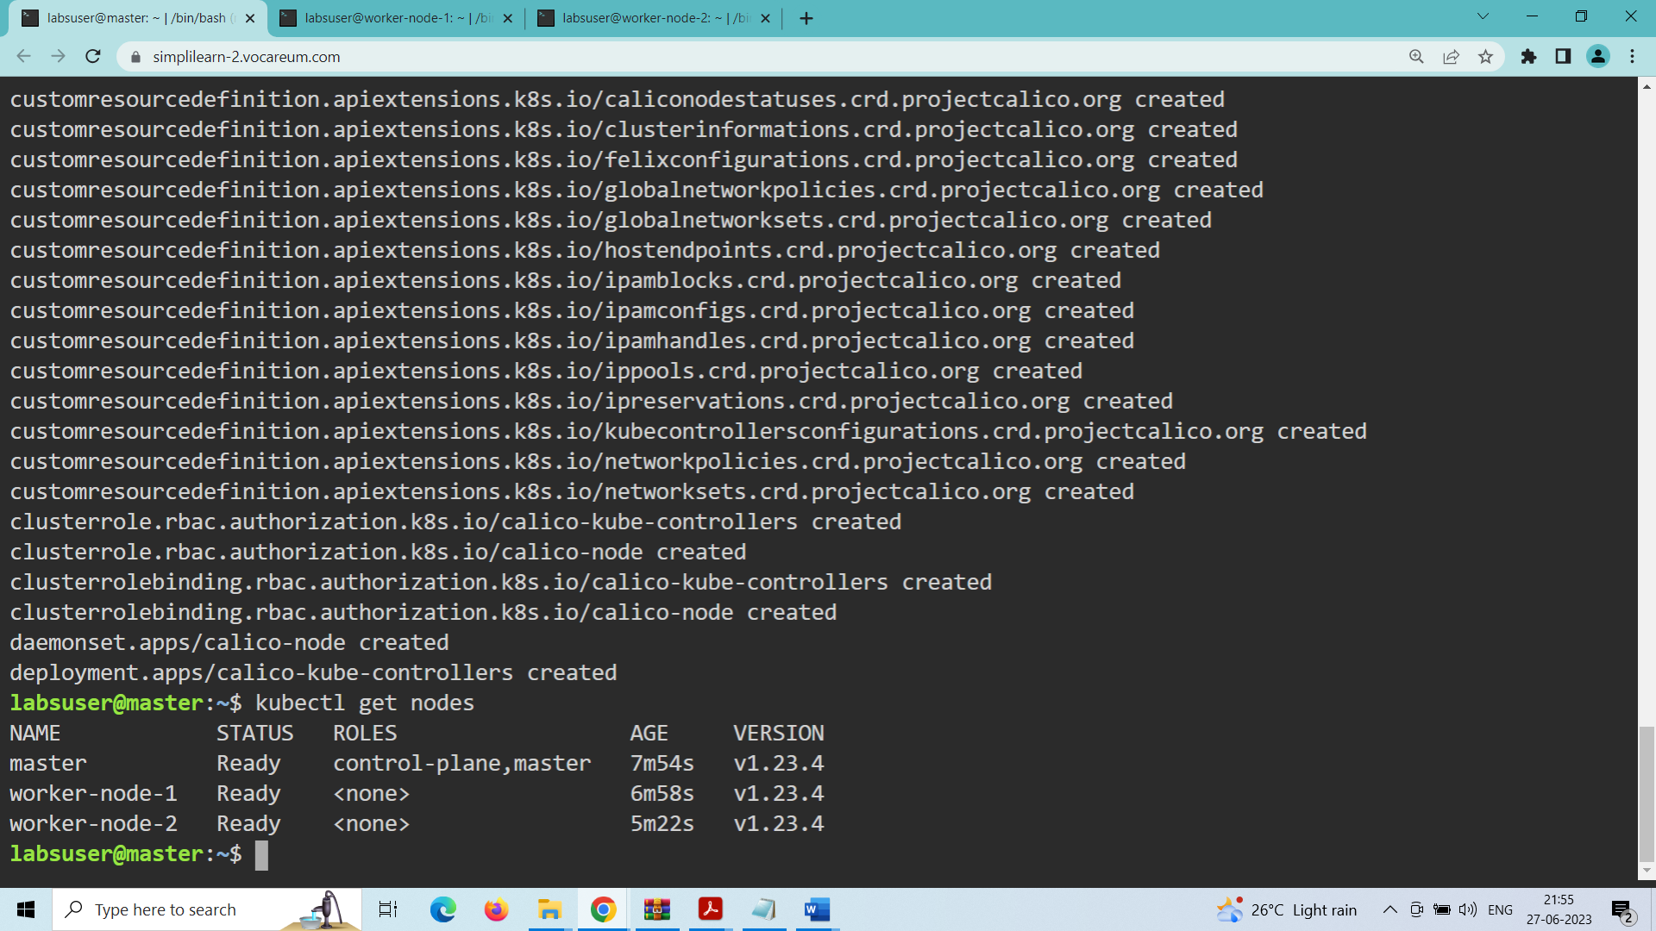

**TASK-1: To back up the etcd cluster data**

1. **Use the following command to install the etcd-client:**

sudo apt install etcd-client

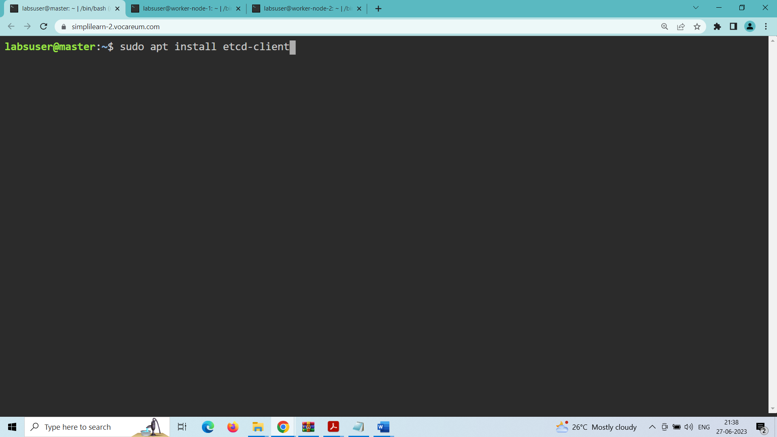

List all the pods of the kube-system namespace:

Kubectl get pods -n kube-system

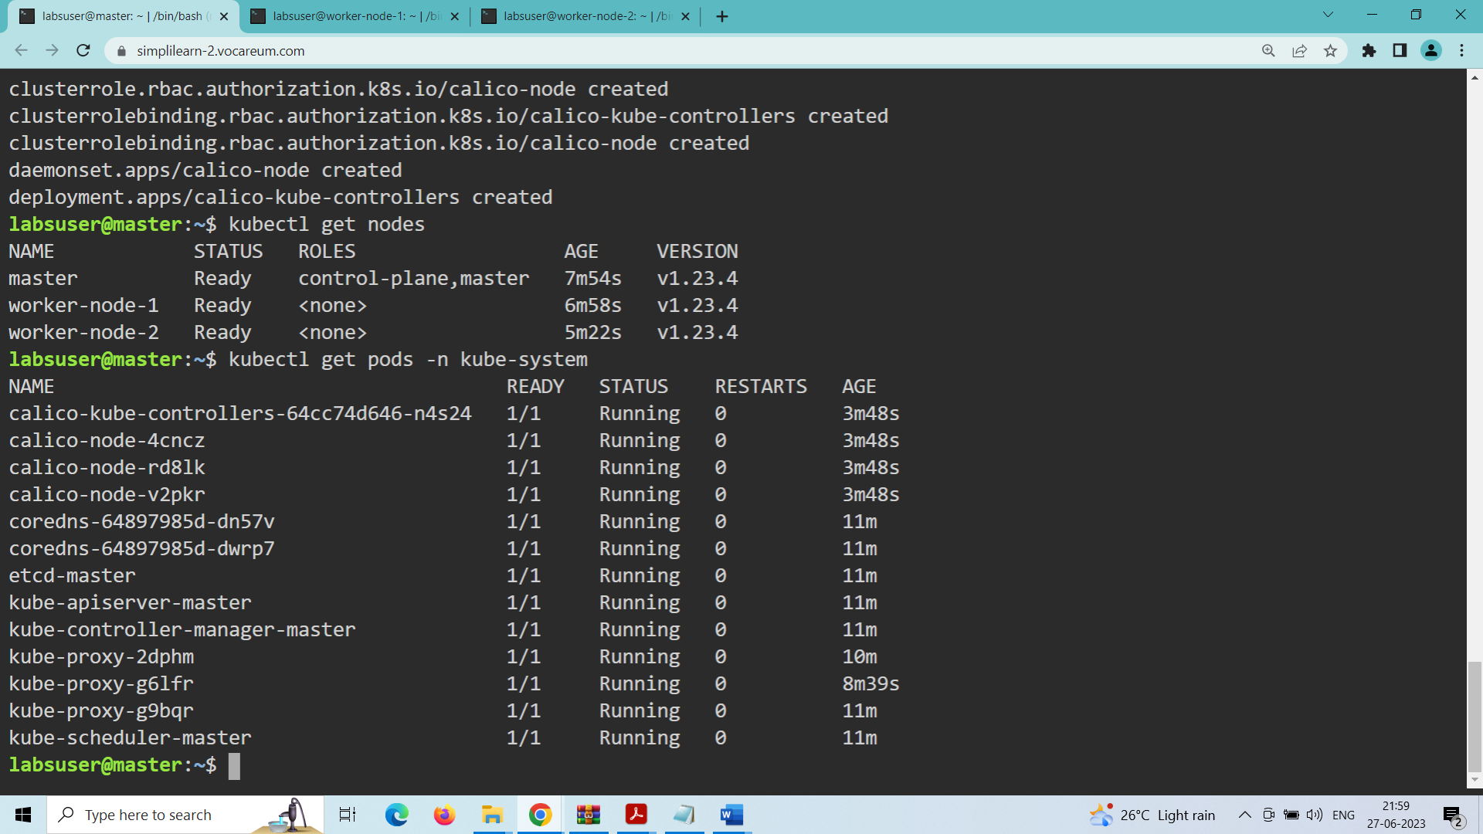

Describe the etcd pod of the kube-system namespace and copy the IP address of the --advertise-client-url flag:

kubectl describe pods etcd-master -n kube-system

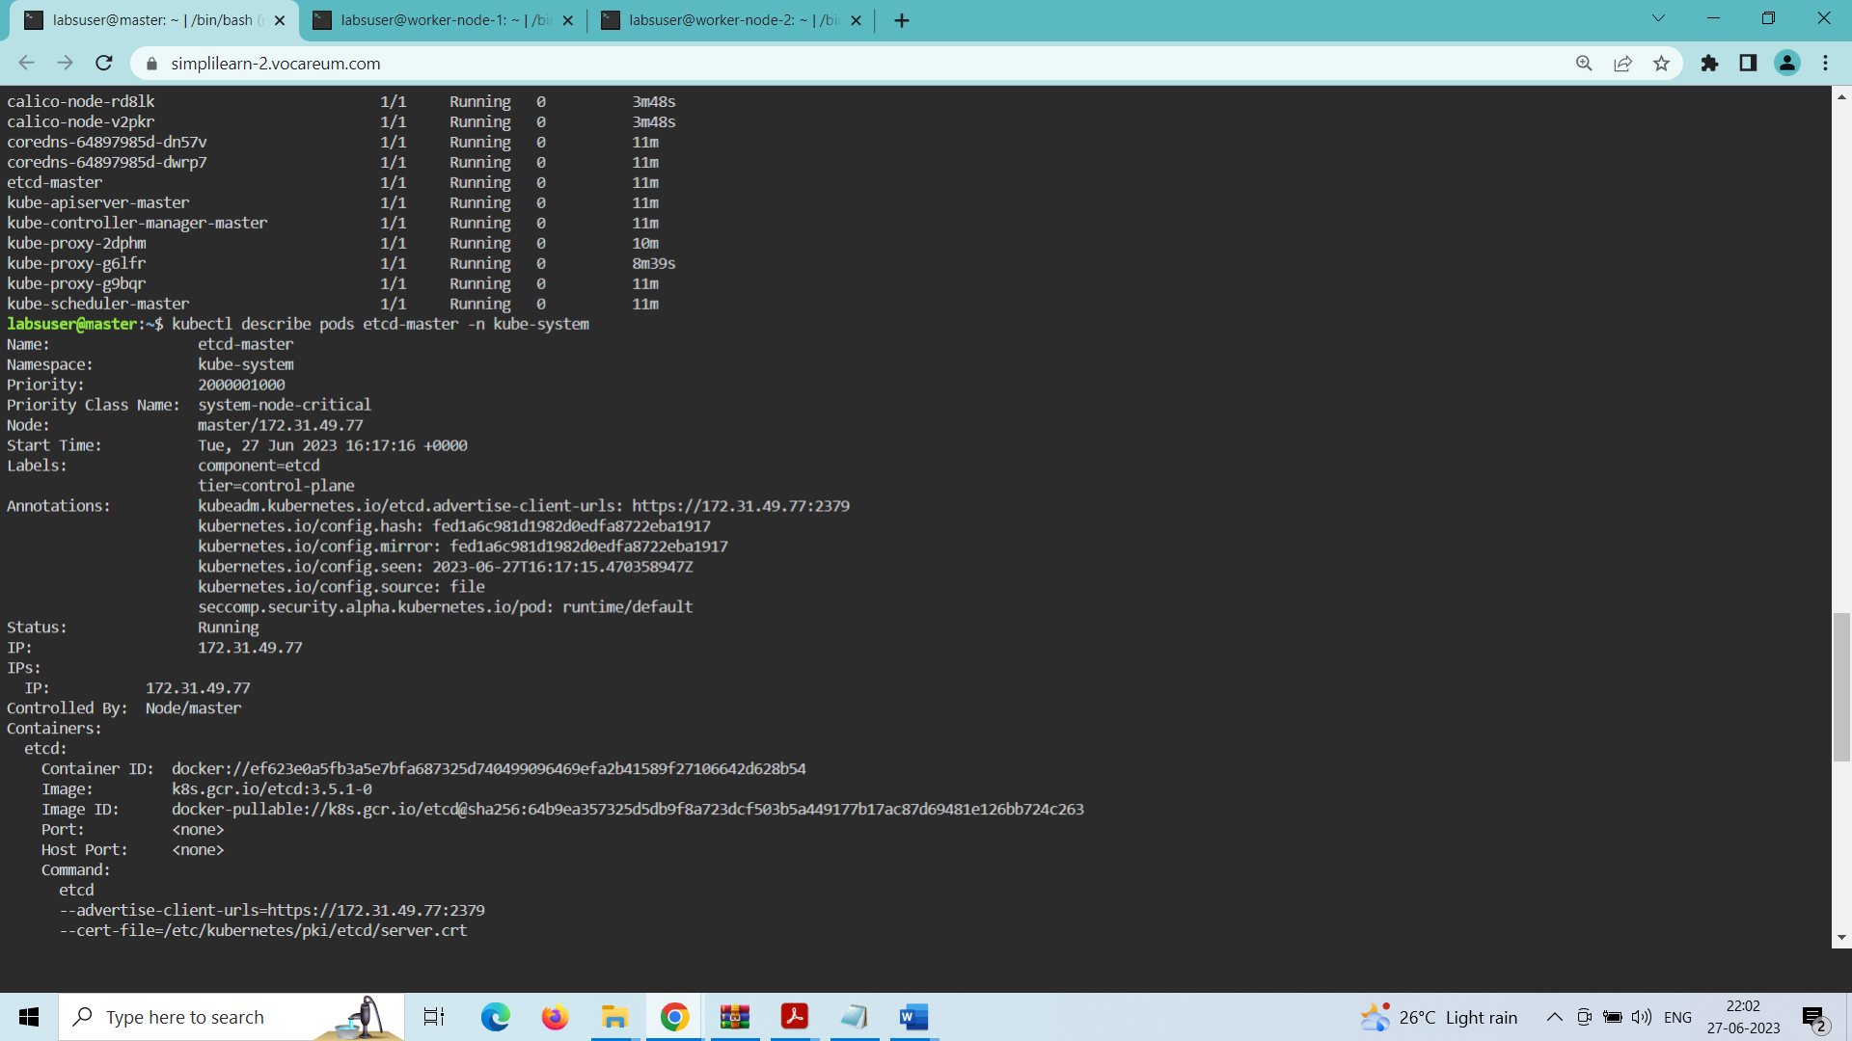

Export the advertise-client-url to advertise_url:

export advertise_url=https://172.31.49.77:2379

echo $advertise_url

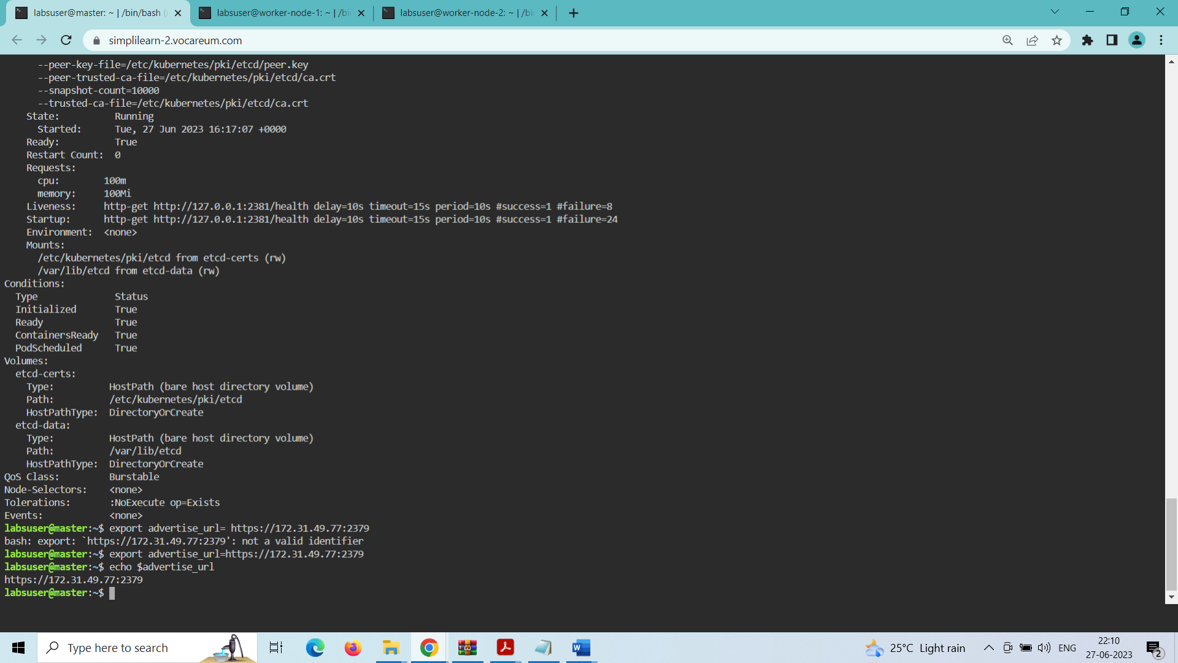

Use the following command to save the etcd backup:

sudo ETCDCTL_API=3 etcdctl \

--endpoints $advertise_url \

--cacert /etc/kubernetes/pki/etcd/ca.crt \

--key /etc/kubernetes/pki/etcd/server.key \

--cert /etc/kubernetes/pki/etcd/server.crt snapshot save /tmp/myback

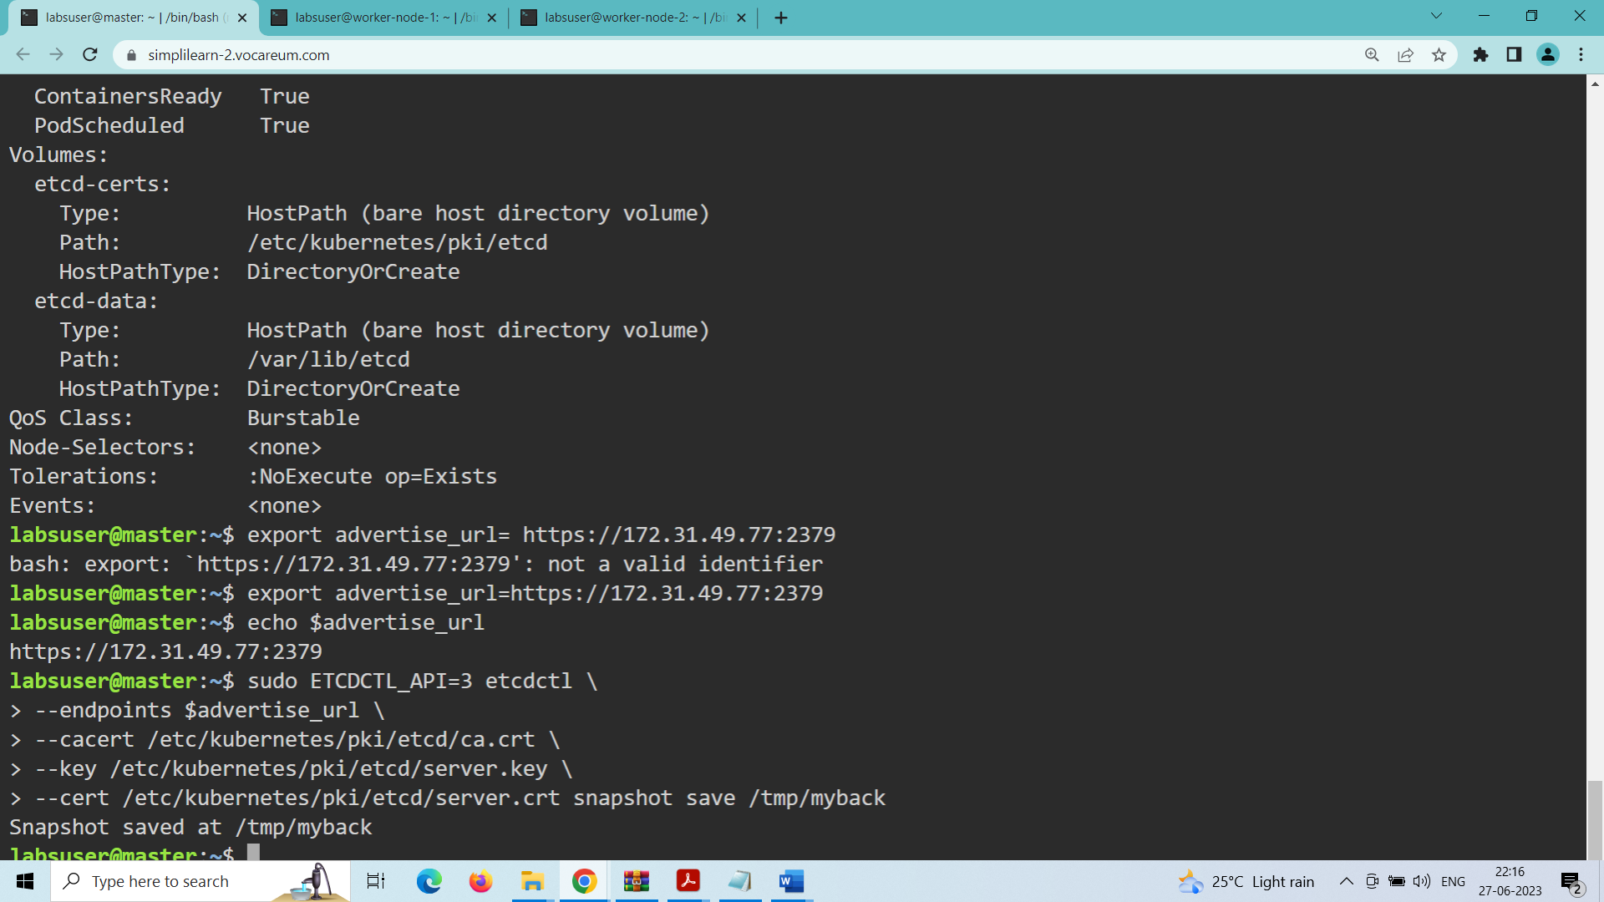

Use the ls command to check the newly created backup file:

ls /tmp

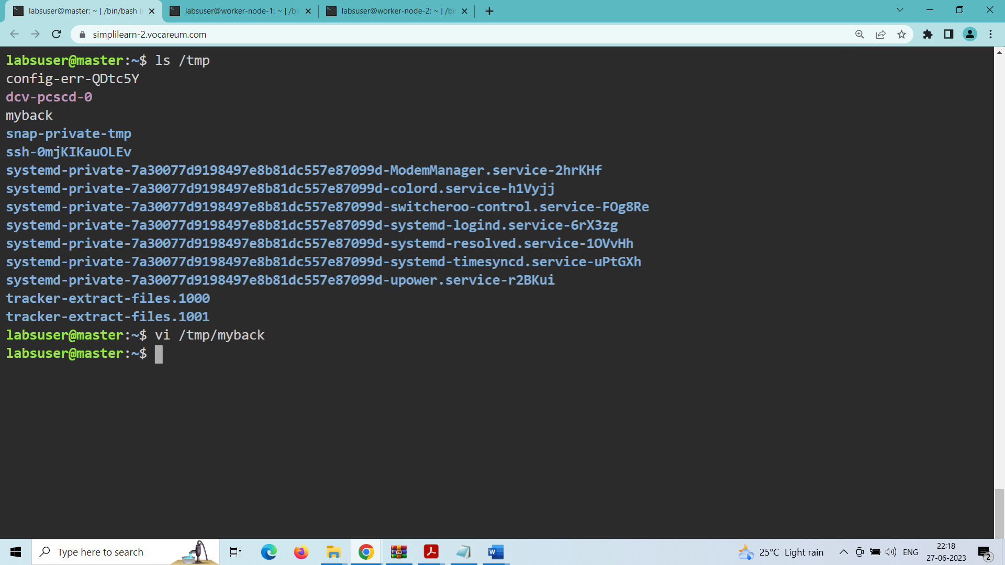

Backup is stored in the /tmp/myback file

**TASK-2: To create and verify the namespaces**

1. Create a namespace by using the following command:

kubectl create namespace cep-project2

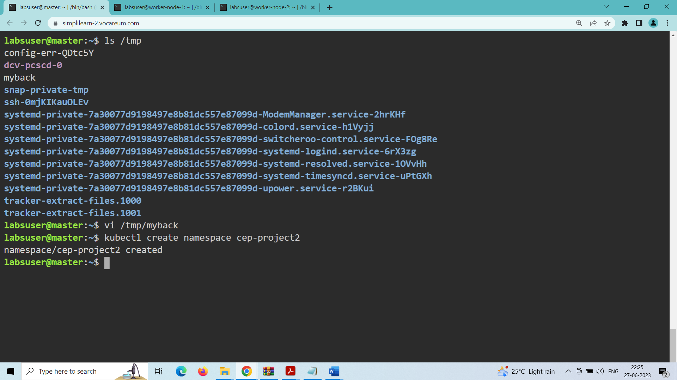

Create a directory cep-project2

mkdir cep-project2

cep-project2

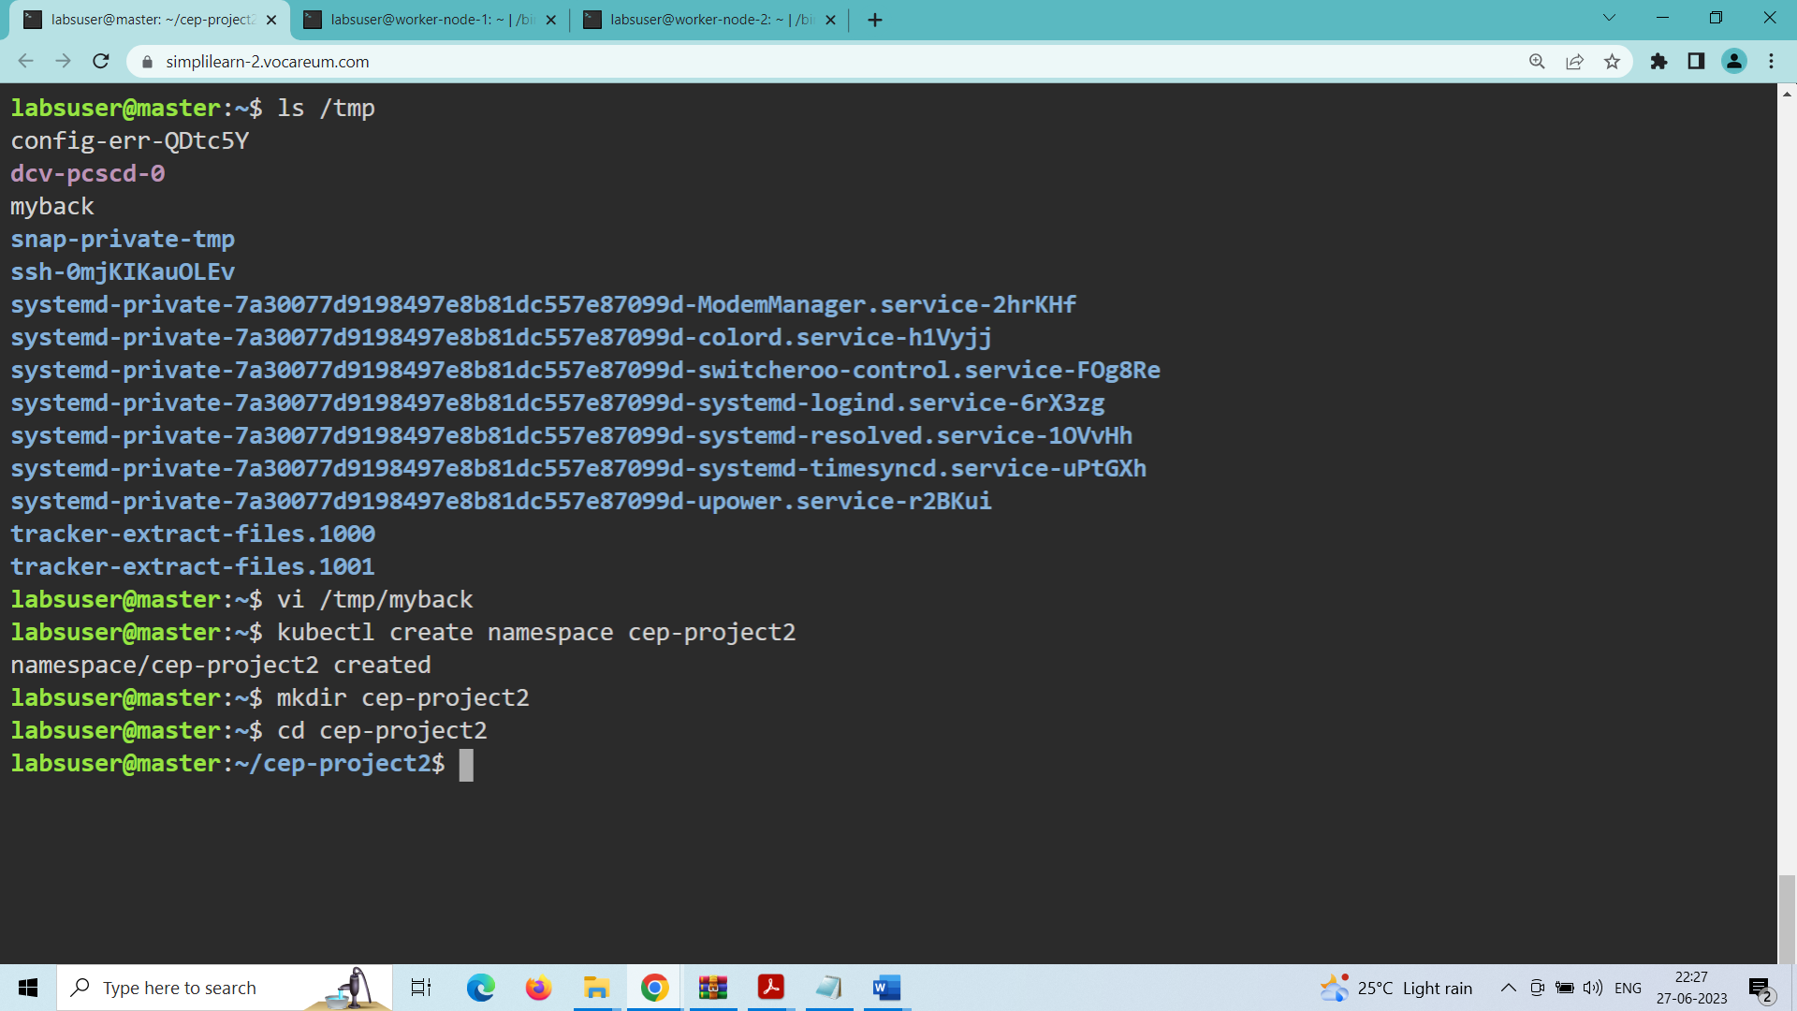

Created a deployment in the namespace cep-project2:

vi deploy1.yaml

Add the following script inside the file:

apiVersion: apps/v1

kind: Deployment

metadata:

  name: my-deployment

namespace: cep-project2

spec:

  replicas: 3

  selector:

    matchLabels:

      app: nginx

  template:

    metadata:

      labels:

        app: nginx

    spec:

      containers:

      - name: nginx

        image: nginx:1.14.2

        ports:

        - containerPort: 80

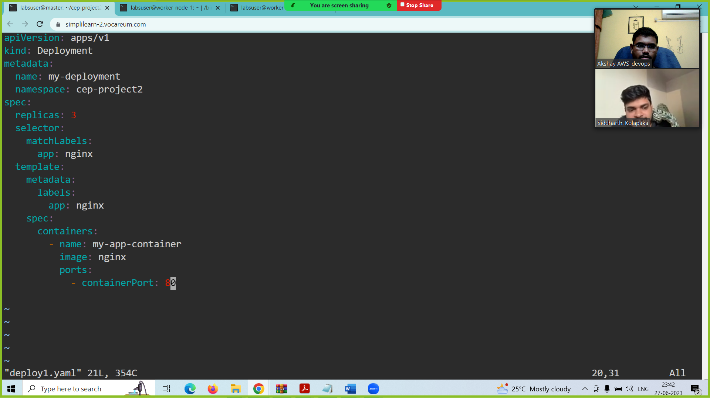

kubectl apply -f deploy1.yaml

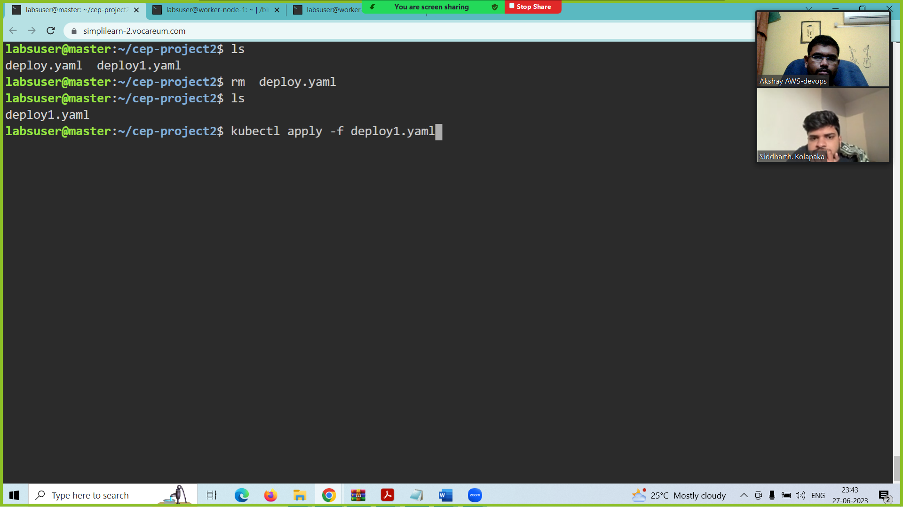

A deployment with name my-deployment is created in the namespace cep-project2

**TASK-3: To generate a certificate and private key:**

To generate an RSA private key, run the following command:

sudo openssl genrsa -out user4.key 2048

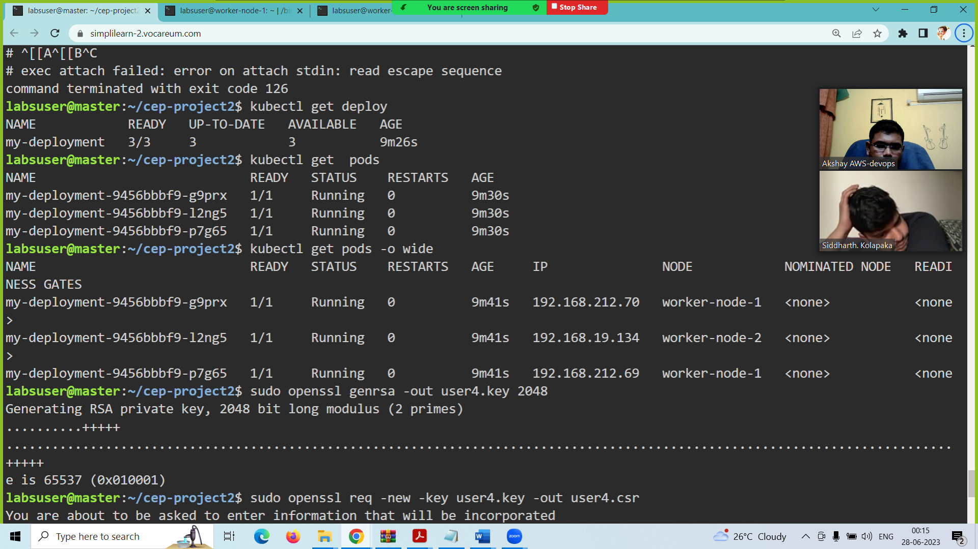

Use the following command to generate certificate requests:

sudo openssl req -new -key user4.key -out user4.csr

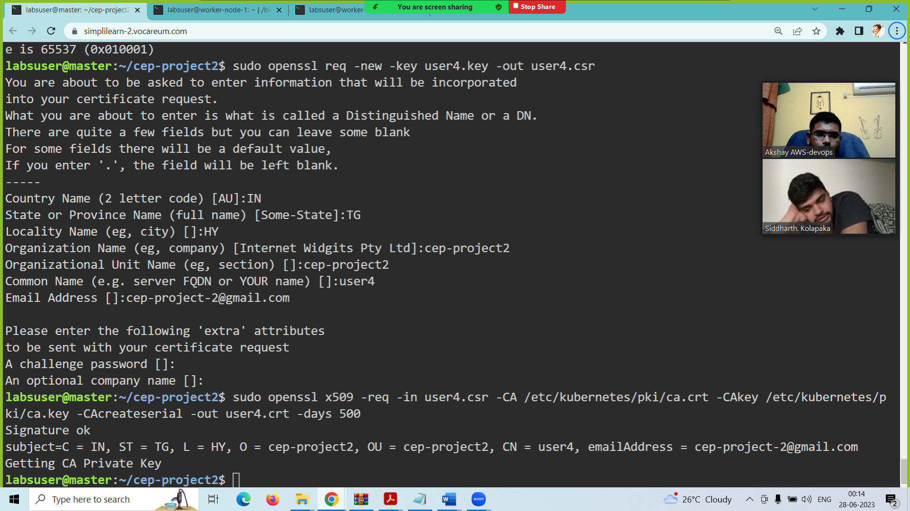

Run the following command to link an identity to a private key using a digital signature:

sudo openssl x509 -req -in user4.csr -CA /etc/kubernetes/pki/ca.crt -CAkey /etc/kubernetes/pki/ca.key -CAcreateserial -out user4.crt -days 500

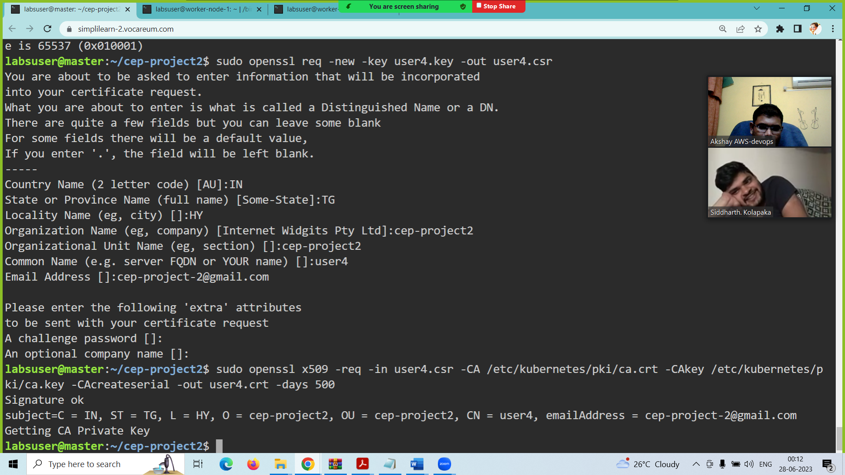

To create a role, add the following code to the viewaccess.yaml file:

vi viewaccess.yaml

kind: Role

apiVersion: rbac.authorization.k8s.io/v1

metadata:

namespace: cep-project2

name: user4

rules:

- apiGroups: ["", "extensions", "apps"]

resources: ["deployments", "pods", "services"]

verbs: ["get", "list", "watch"]

This script allows only view access to the user4.

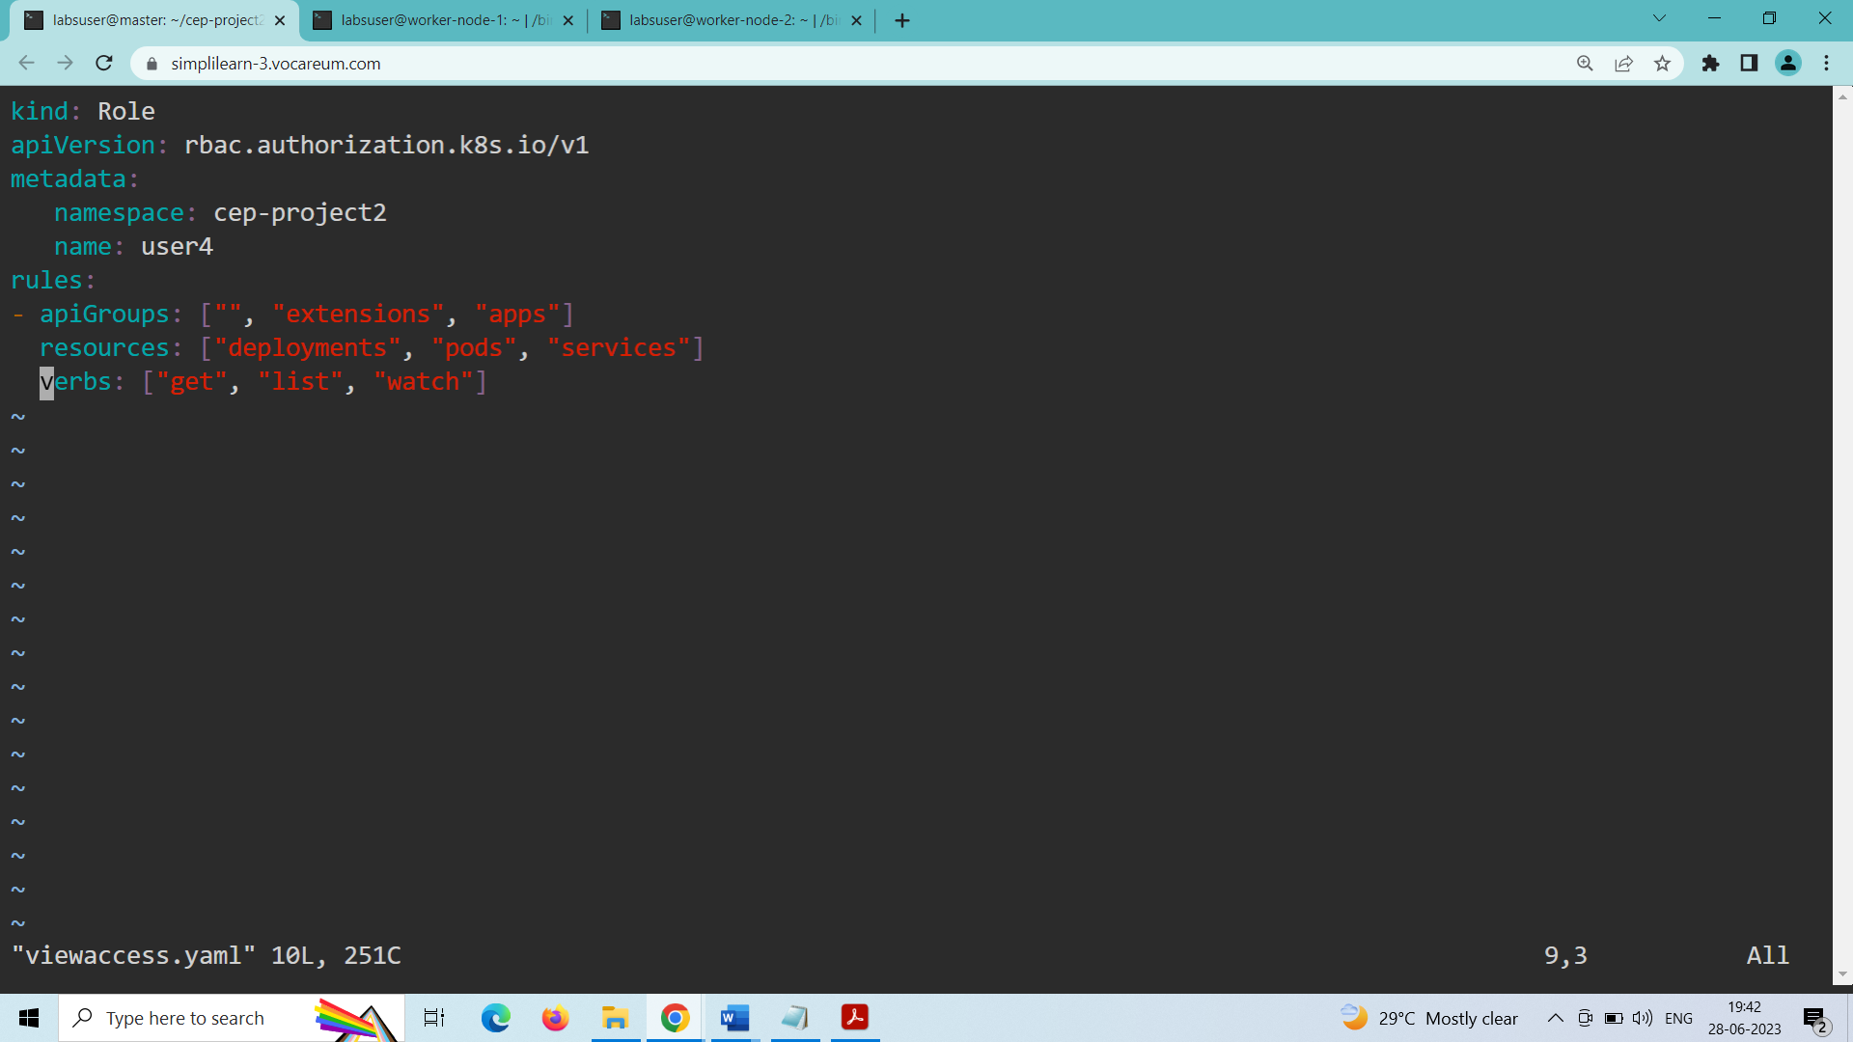

kubectl create -f viewaccess.yaml

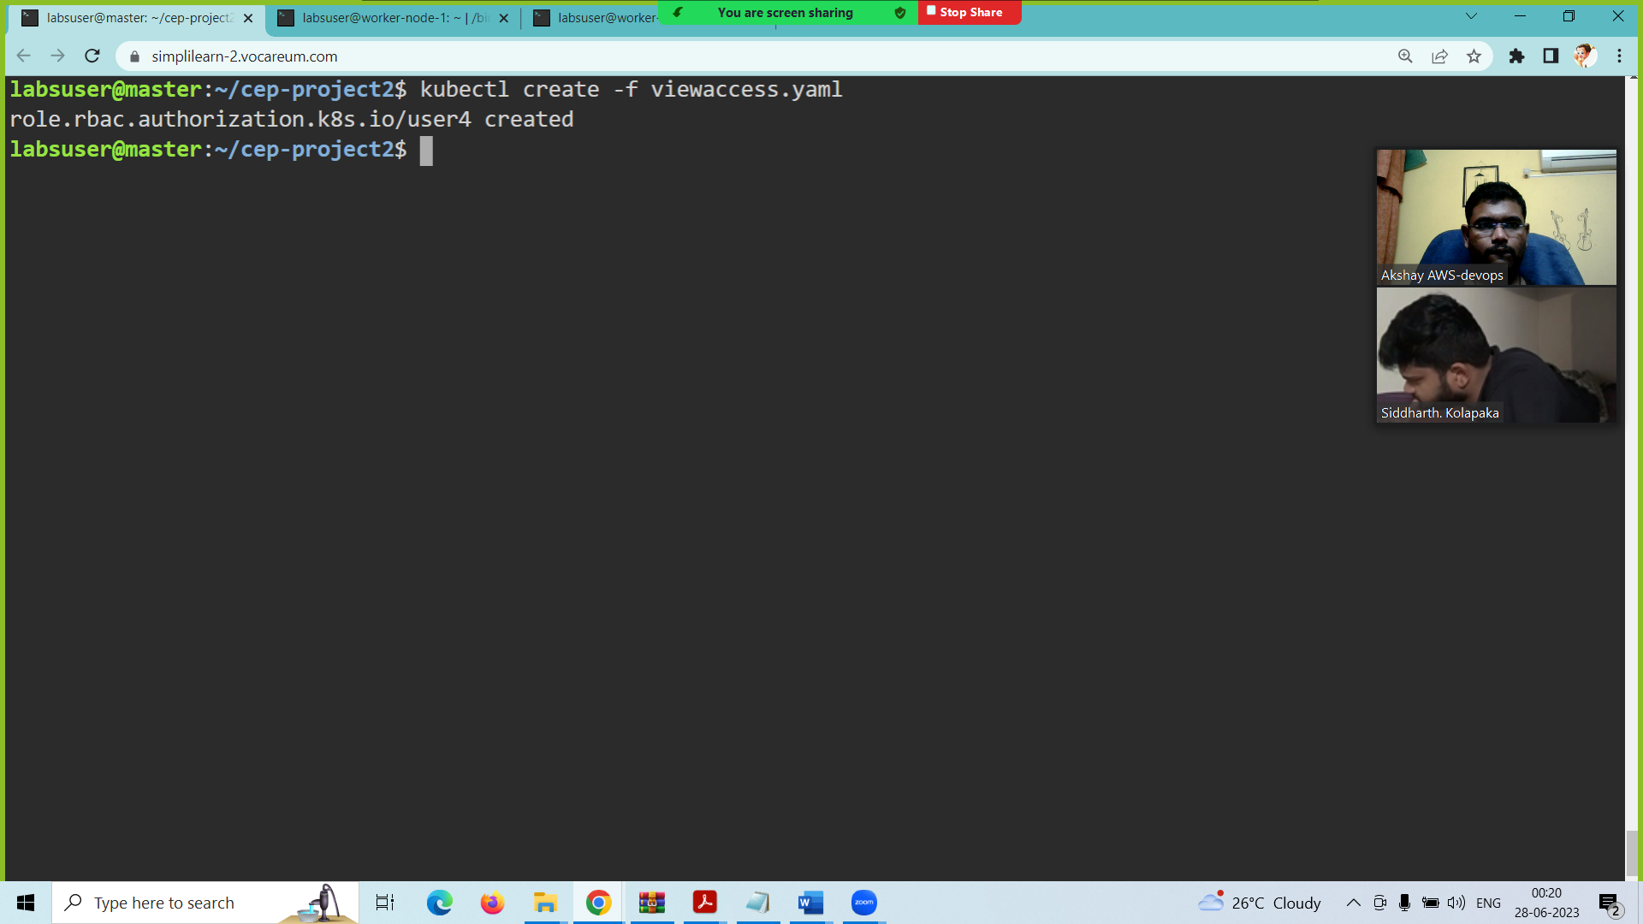

kubectl get roles -n cep-project2

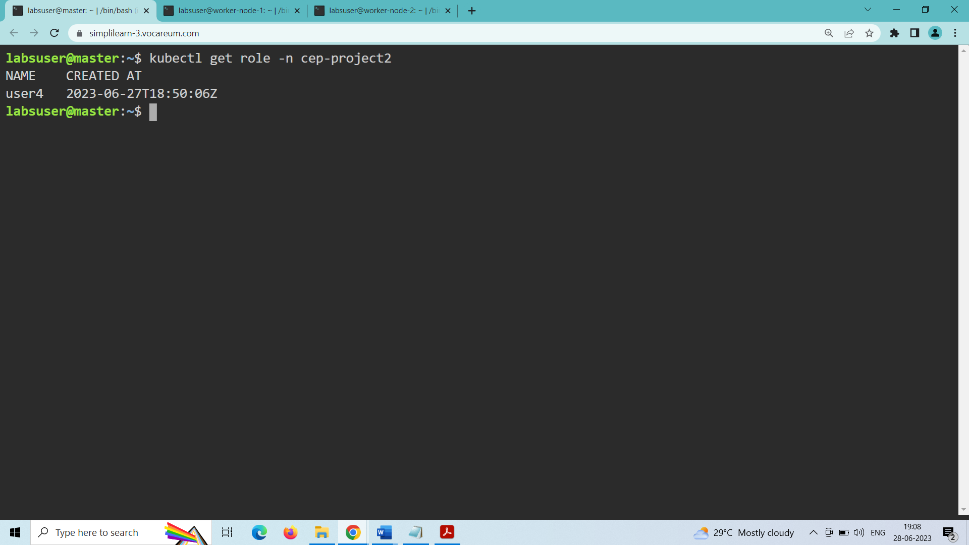

A role with the name user4 is created.

Creating a rolebinding

To create a rolebinding, add the following code to the rolebinding.yaml file.

vi rolebinding.yaml

kind: RoleBinding

apiVersion: rbac.authorization.k8s.io/v1

metadata:

name: role-test

namespace: cep-project2

subjects:

- kind: User

name: user4

apiGroup: ""

roleRef:

kind: Role

name: user4-role

apiGroup: ""

Create rolebinding by using the following command:

kubectl create -f rolebinding.yaml

kubectl get rolebinding -n cep-project2

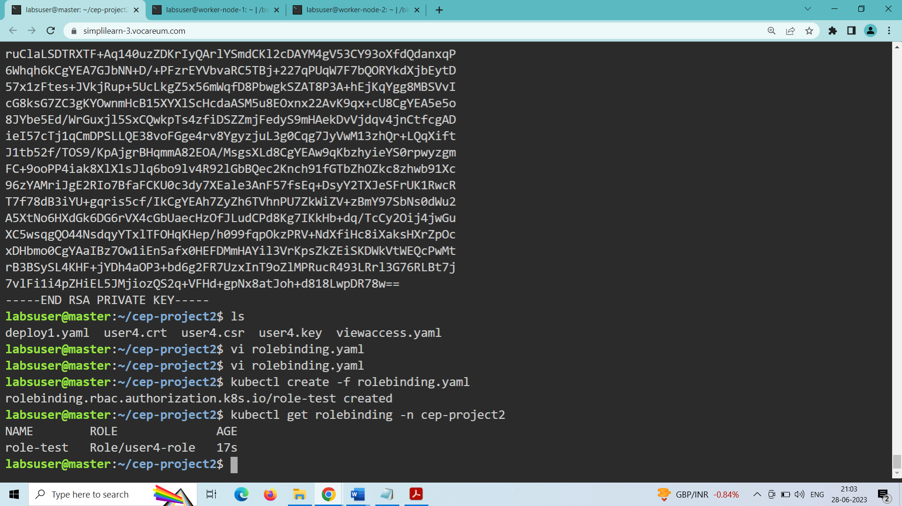

Set credentials to user4:

kubectl config set-credentials user4 –client certificate=/home/labsuser/cep-project2/user4.crt –client key=/home/labsuser/cep-project2/user4.key

Set context to user4:

kubectl config set-context user4-context --cluster=kubernetes --namespace=cep-project2 --user=user4

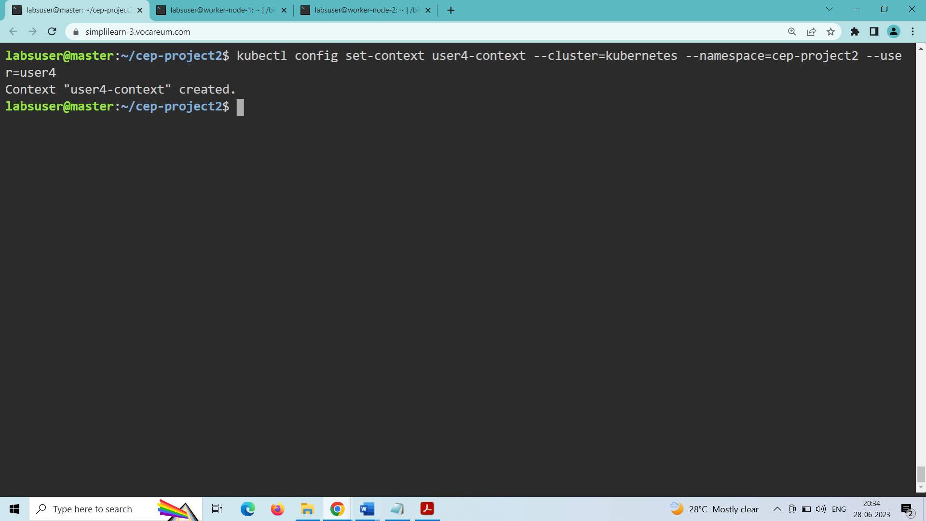

Run the following command to display current contexts:

kubectl config get-contexts

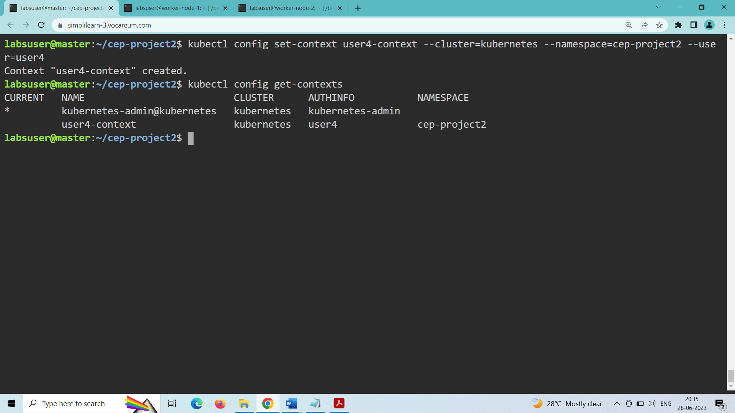

Copying the config file to the client machine

Copy the config file from the master node in the home directory.

cd ..

cat .kube/config

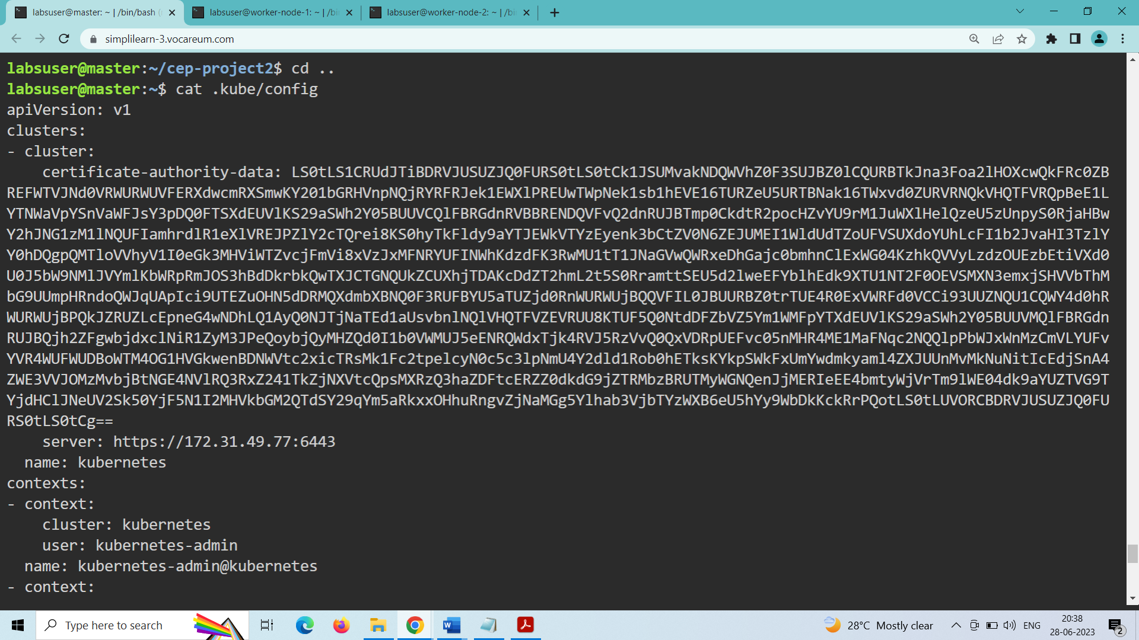

Paste the copied config file into the client machine:

Create a myconf file inside the worker node and paste the contents of the .kube/config file inside the myconf file

vi myconf

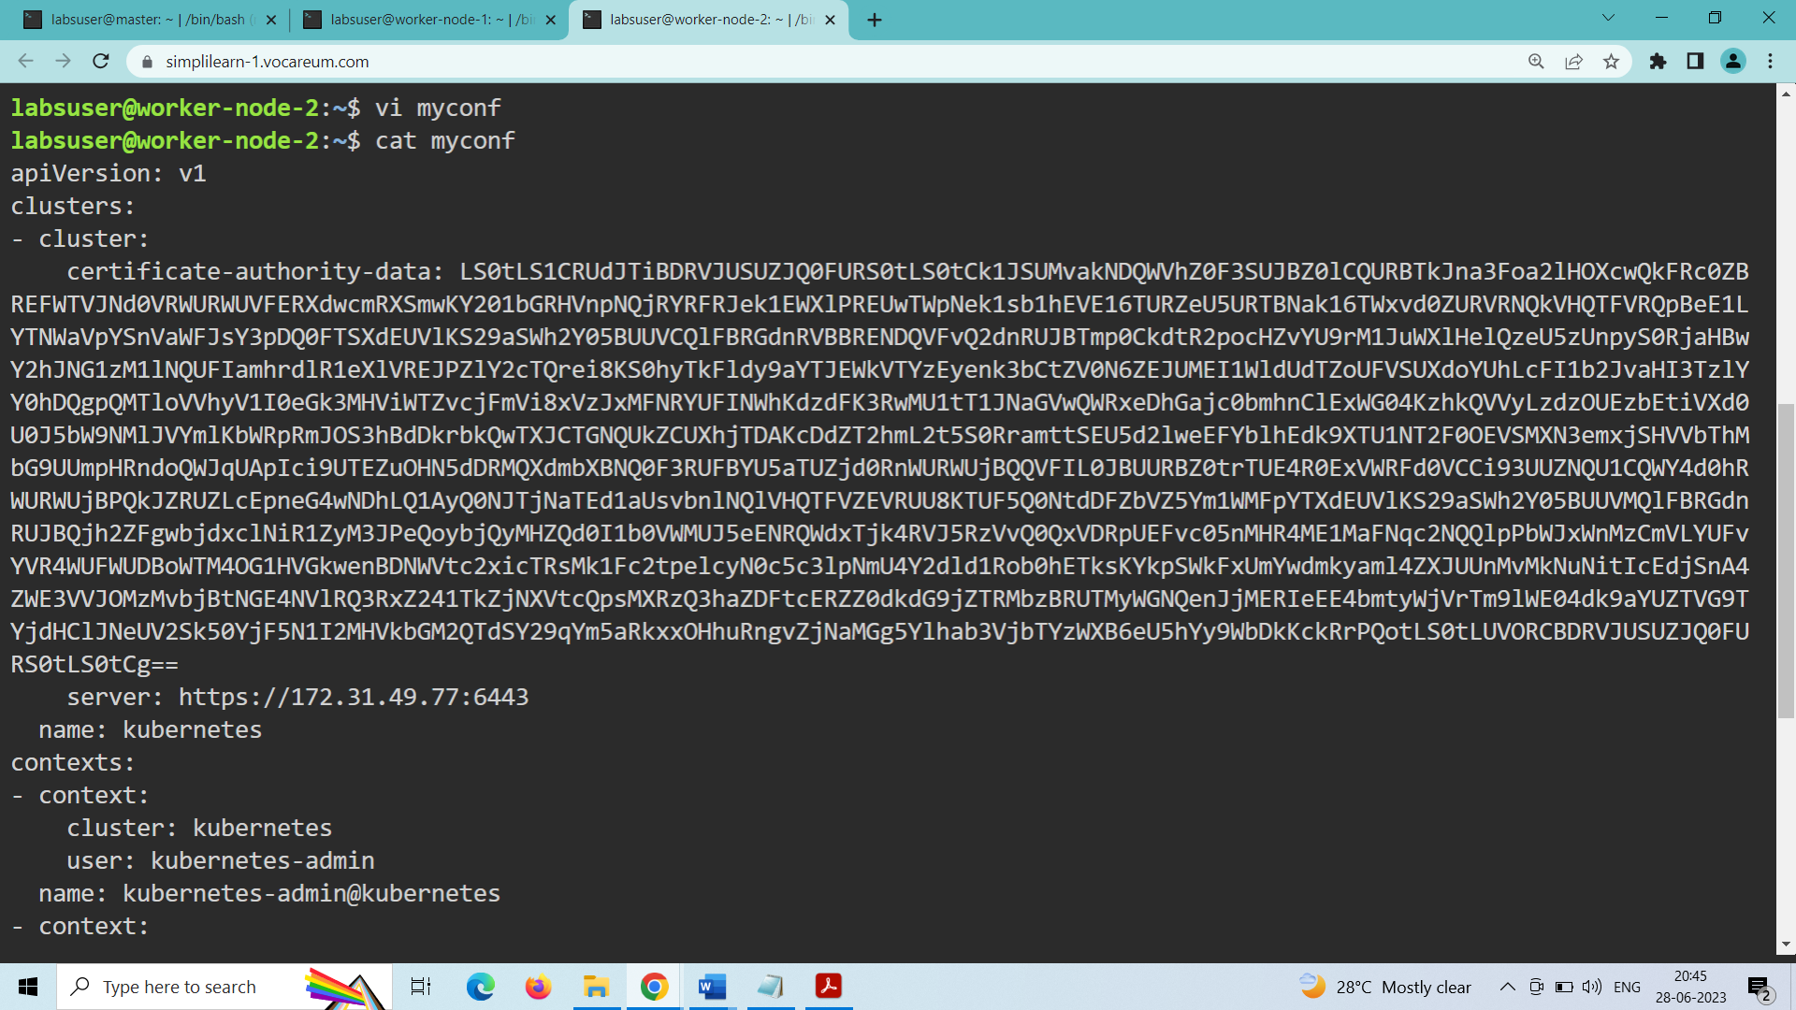

Copy the crt and key files from the master node to the client node in the /cep-project2 directory.

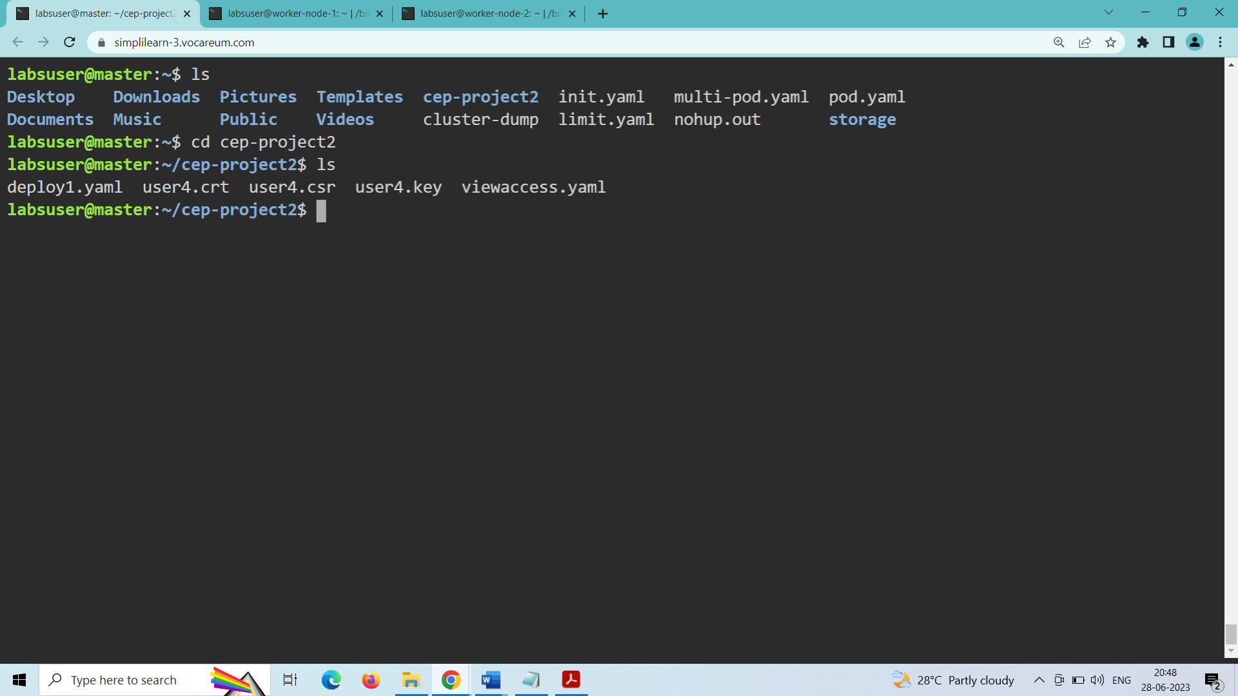

Inside the worker node:

mkdir cep-project2

cd cep-project2

vi user4.crt

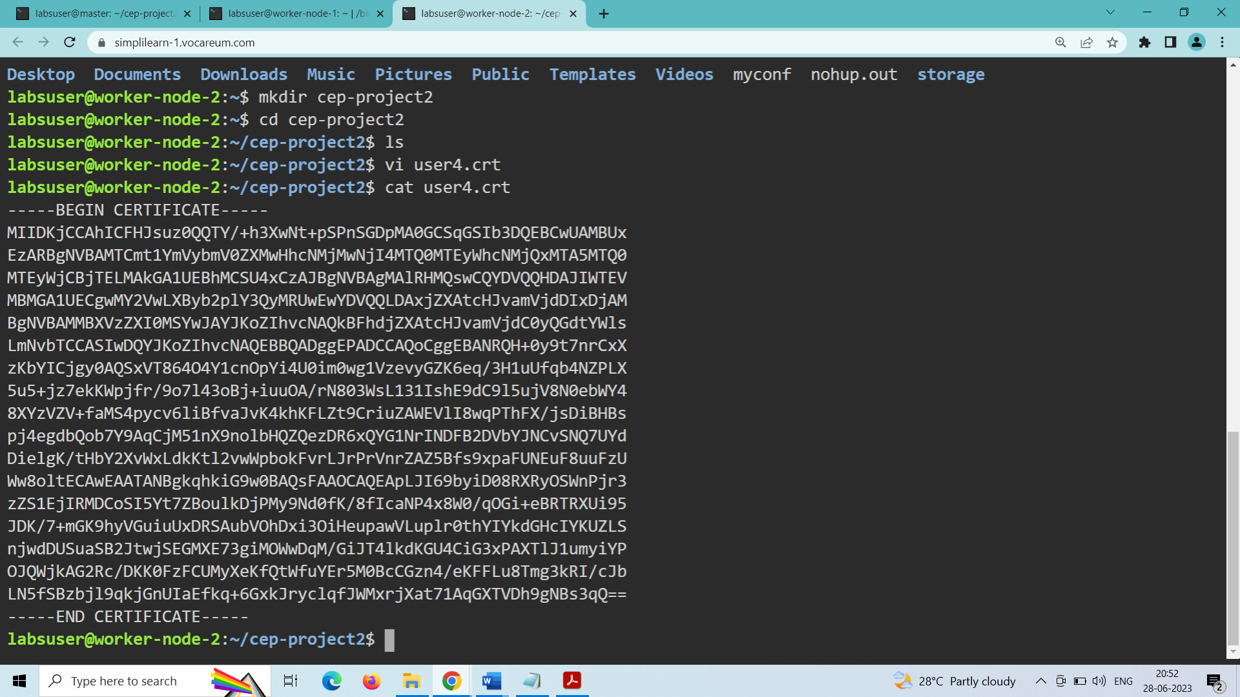

vi user4.key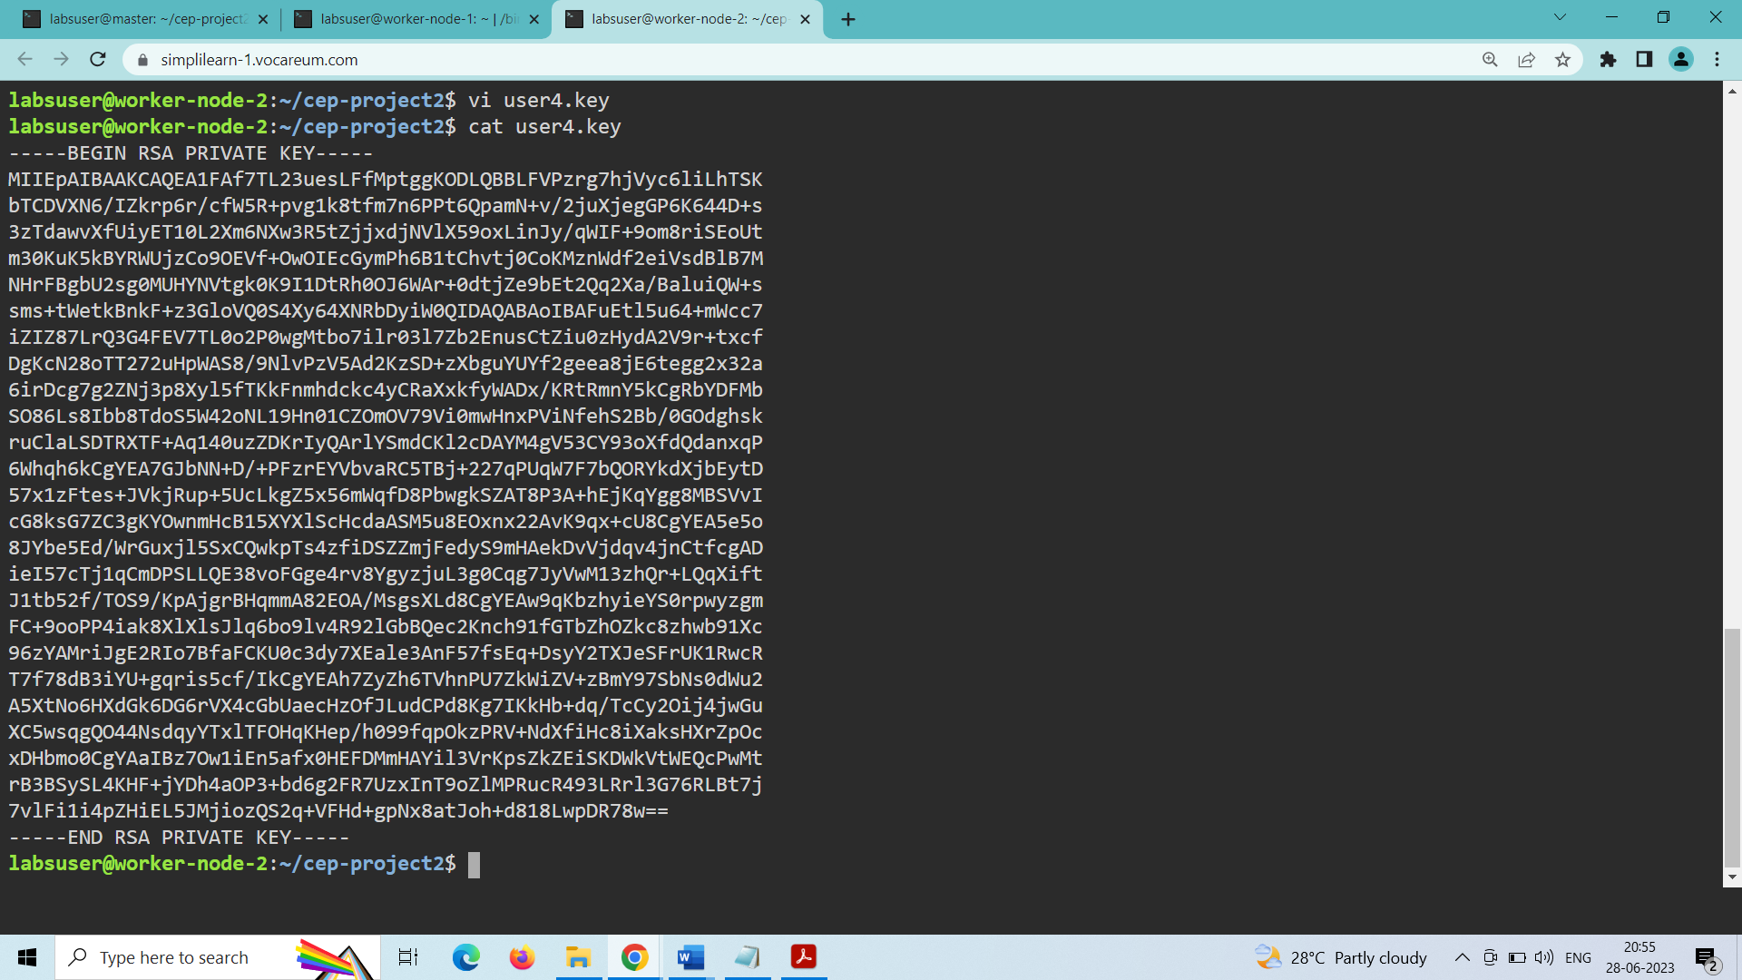

Run the following commands to verify roles we have generated:

Kubectl get pods -n cep-project2 –kubeconfig=myconf

Kubectl get deployment -n cep-project2 –kubeconfig=myconf

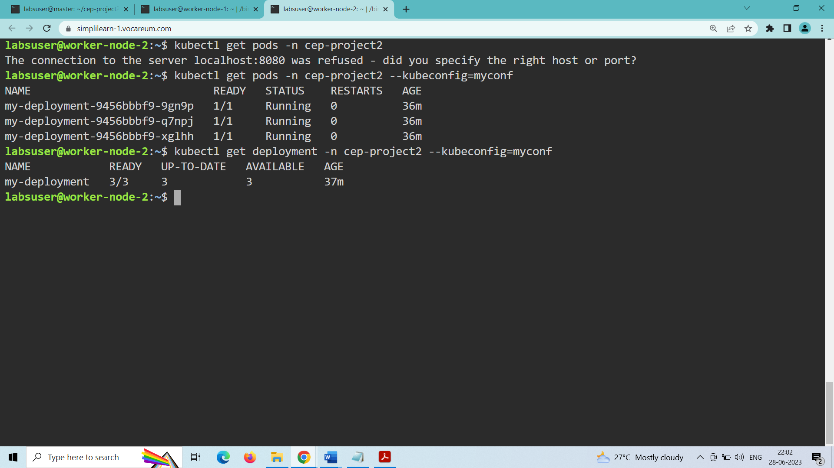

**TASK-4: To upgrade the Kubernetes cluster with the latest**

Determining which version to upgrade

Check which version to upgrade using the following command:

sudo apt update

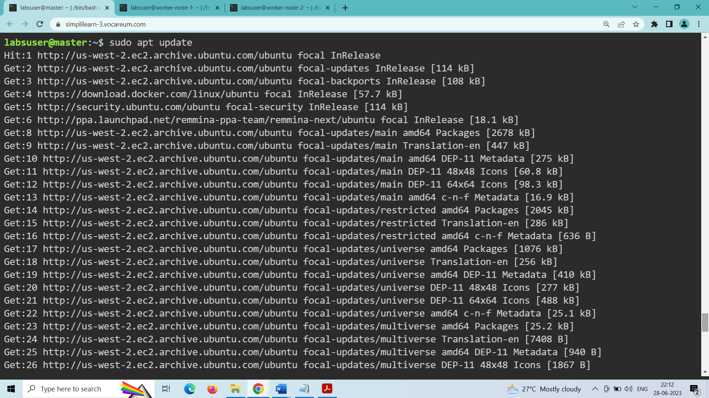

Find the latest patch release of kubeadm 1.23 using the OS package manager:

sudo apt-cache madison kubeadm

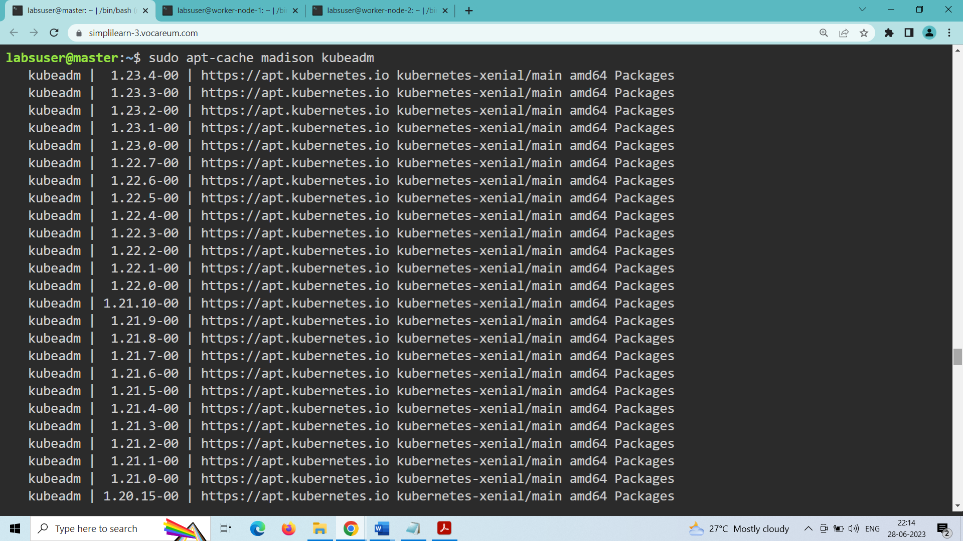

Find the latest patch release of kubectl 1.23 using the OS package manager:

sudo apt-cache madison kubectl

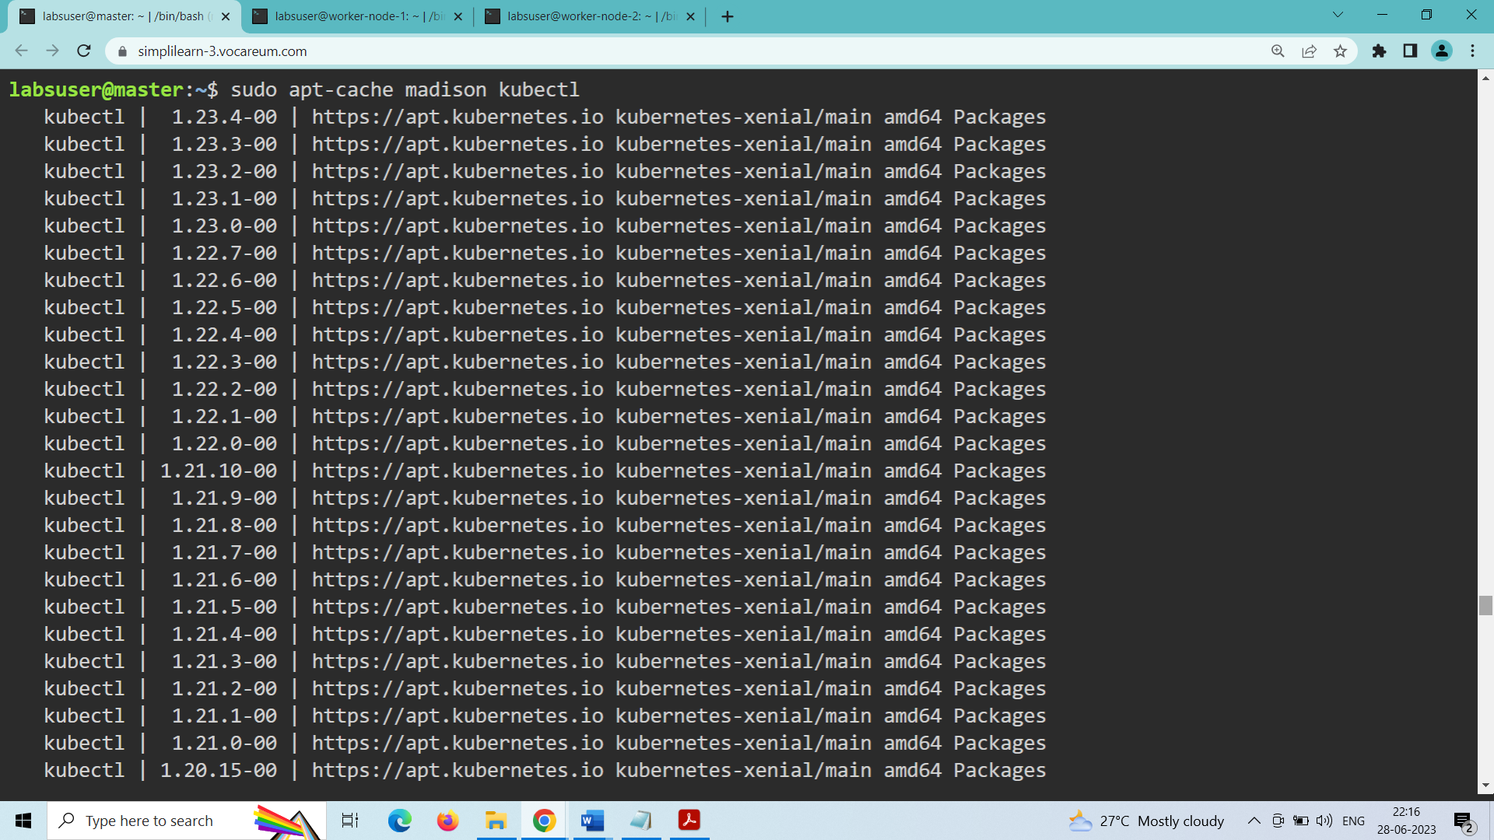

Verify the kubeadm and kubectl versions of the control plane (master):

kubeadm version

kubectl get nodes

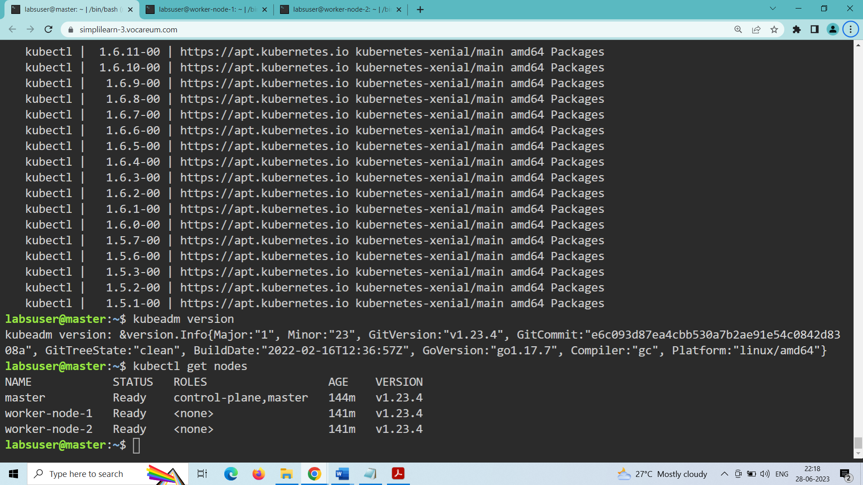

Update and upgrade the repositories using the following commands:

sudo apt update

sudo apt upgrade

Verify the version by using the following command:

kubeadm version

kubectl get nodes

sudo kubeadm upgrade plan

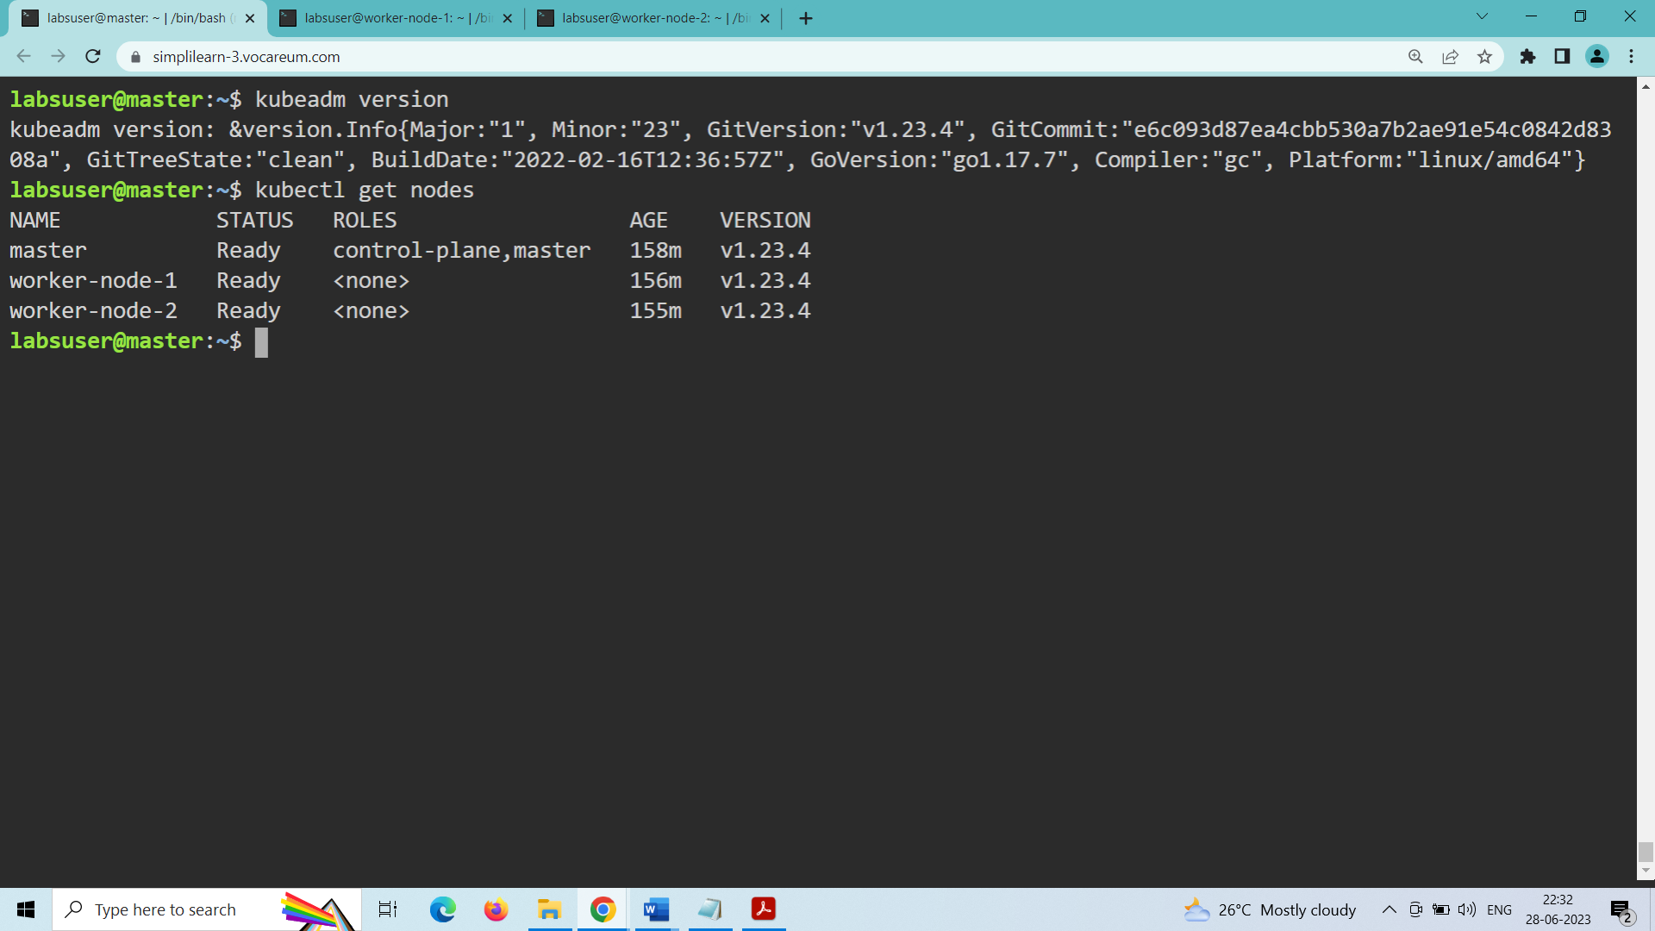

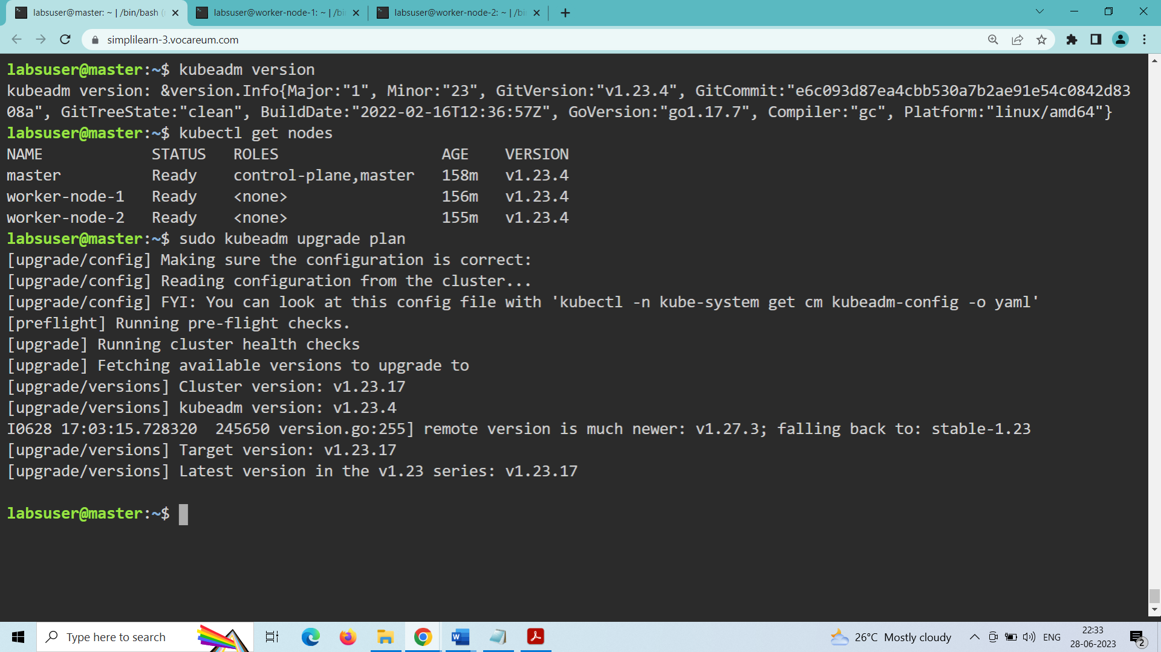

Kubernetes cluster is up to date with the latest version